**Assignment 2 Report**

Github link: <https://github.com/sakethksvlnr/Introduction-to-CV-Assignments>

Q1) Harris corner and Canny edge detection function

Canny:

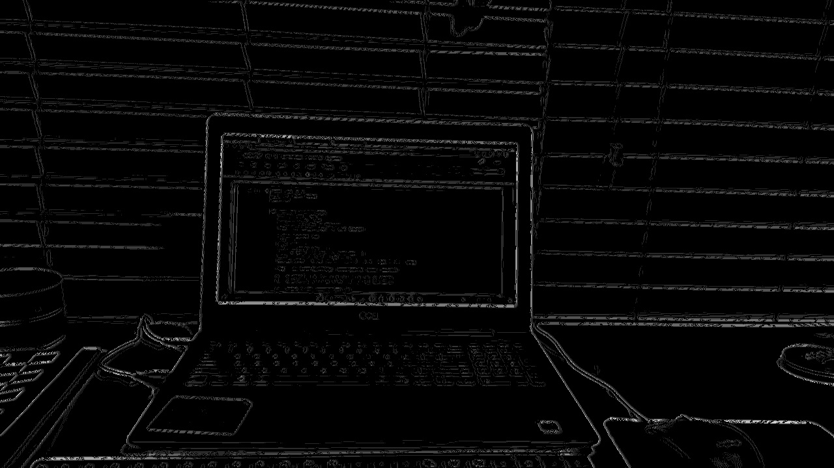

Harris:

Q2) Image stitching:

Test1: Dahlberg Hall

Test2: Student Center East

Test 3: Urban Life

Test 4: Science Center

Test 5: Classroom South

Q3) Integral Image

Q4) SIFT Features Image Stitching:

